Supporting information for:
Outdoor performance of perovskite solar technology: silicon comparison and competitive advantages at different irradiances.
Esteban Velilla*, Daniel Ramirez, José-Ignacio Uribe, Juan F. Montoya and Franklin Jaramillo*
Centro de Investigación, Innovación y Desarrollo de Materiales – CIDEMAT, Universidad de Antioquia UdeA, Calle 70 No. 52-21, Medellín, Colombia.

1. Perovskite solar module architecture

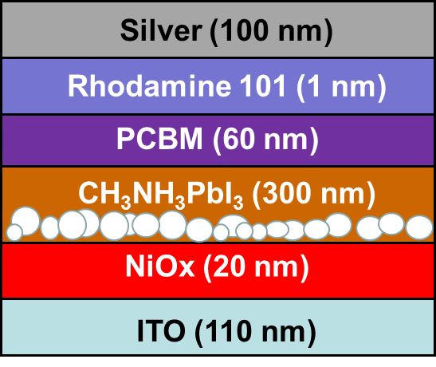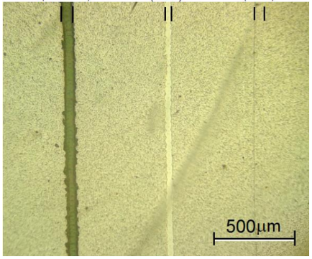
- Architecture b. P1, P2, and P3
Figure S1. Perovskite solar module architecture

2. Atmospheric variables registered
The atmospheric variables registered during the exposure time and their frequency distribution is showed in Figure S2.

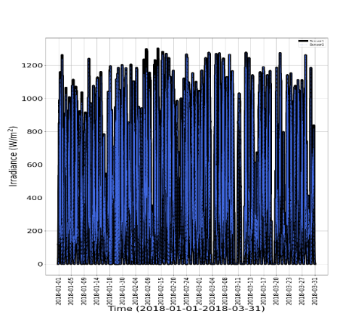 | 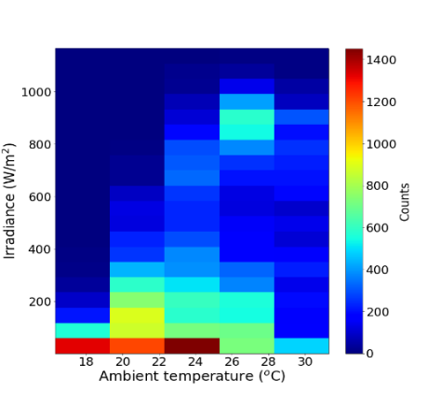
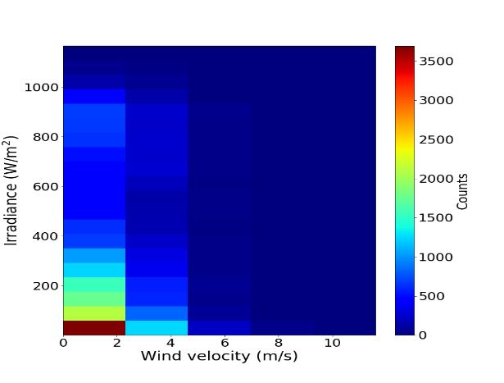 | 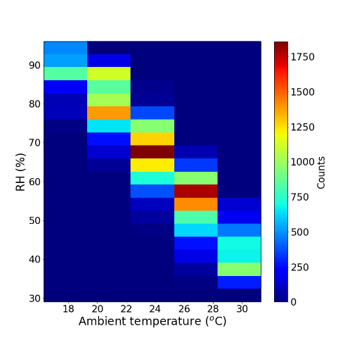
Figure S2. Atmospheric variables and their frequency distribution. a)Irradiance vs time. b) frequency distribution of irradiance vs temperature. c) irradiance vs wind velocity frequency distribution. d) RH vs temperature frequency distribution

3. Stability study of the PSMs
Next figures show the P_{max}, I_{sc} and V_{oc} of the modules evaluated over the exposure time. These variables did not show unusual changes over time and even the last values registered are similar to the initial ones. Additionally, photographs of the PSM show no visual evidence of degradation such as color changes or decoloration.
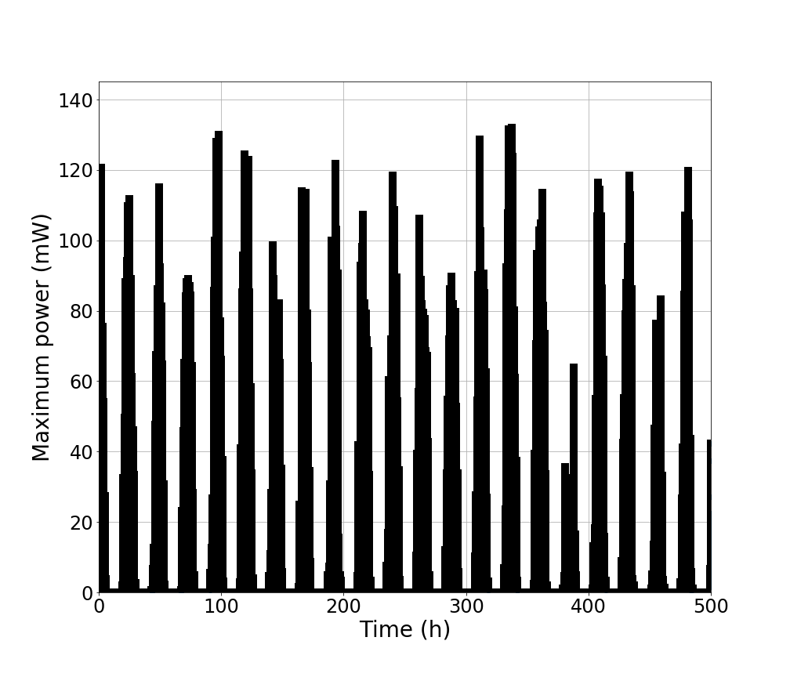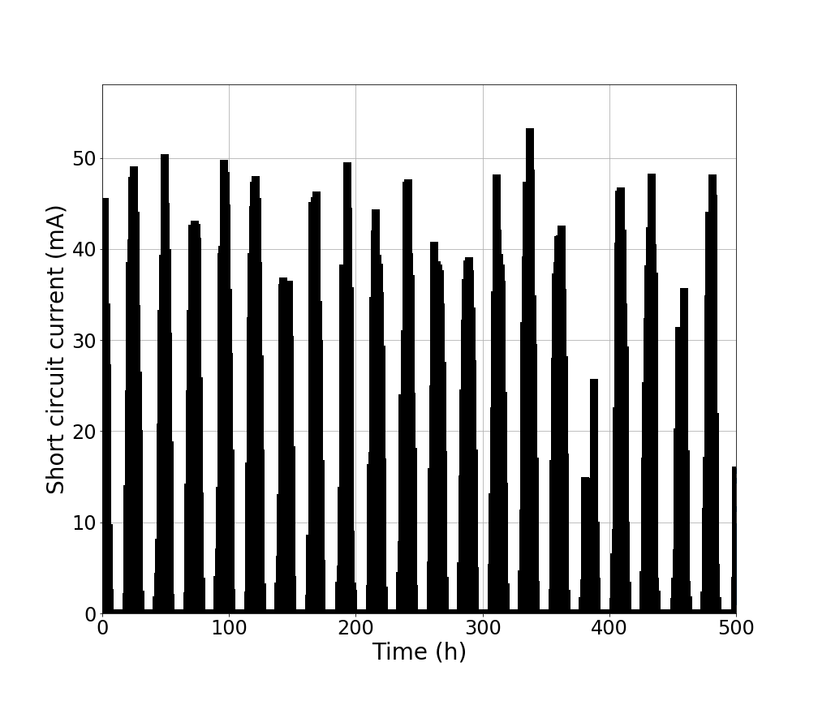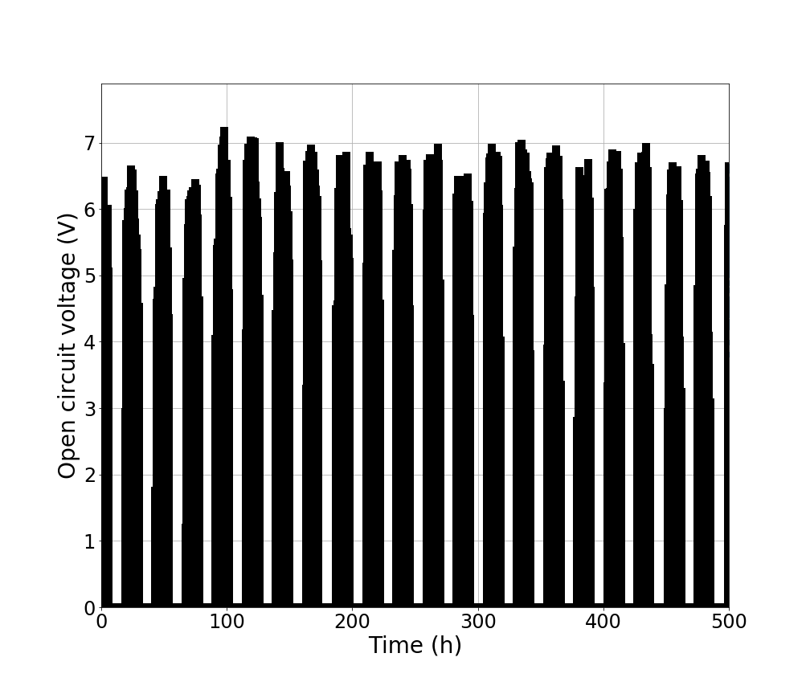
PSM 17 cm²

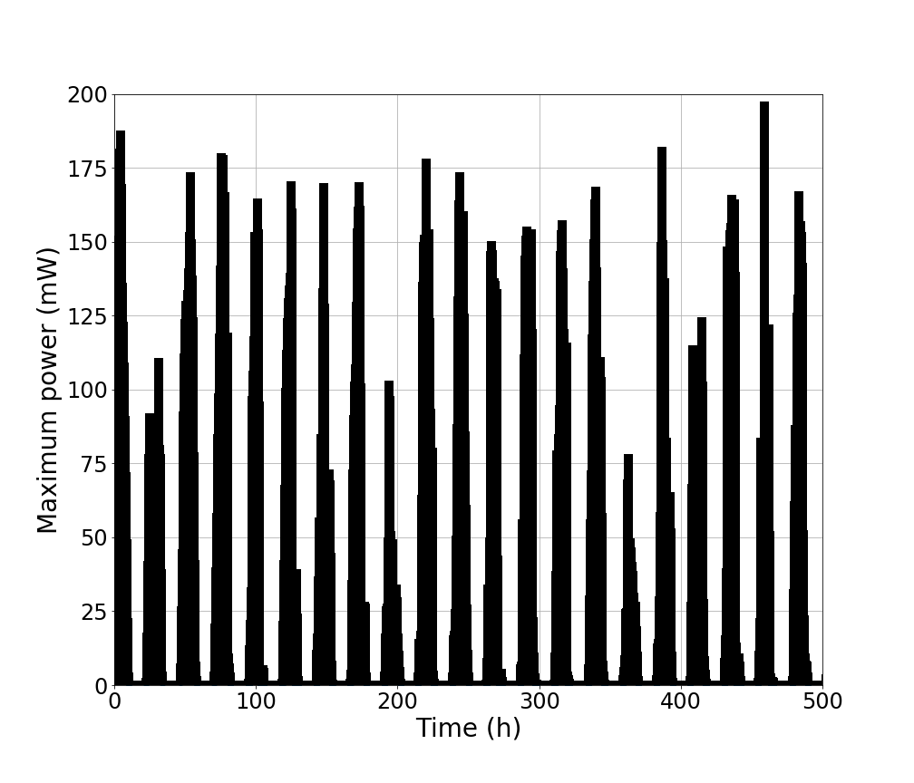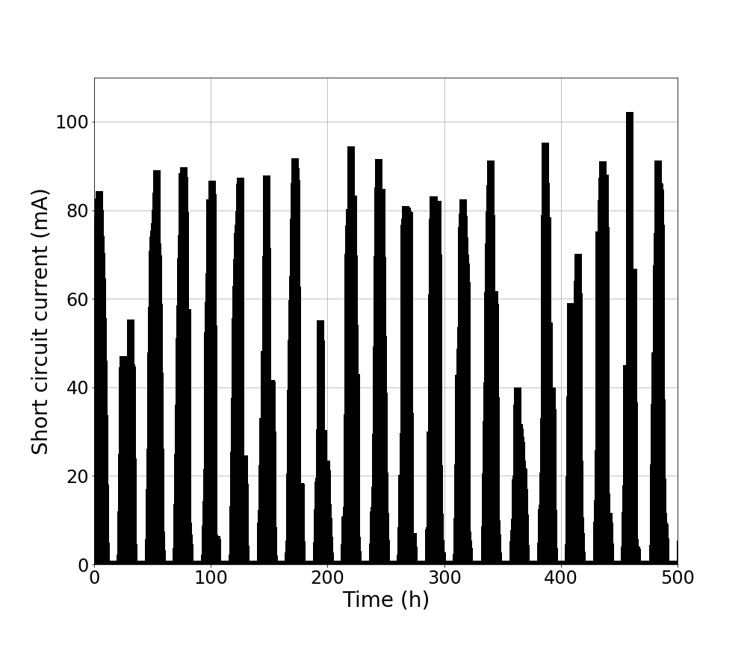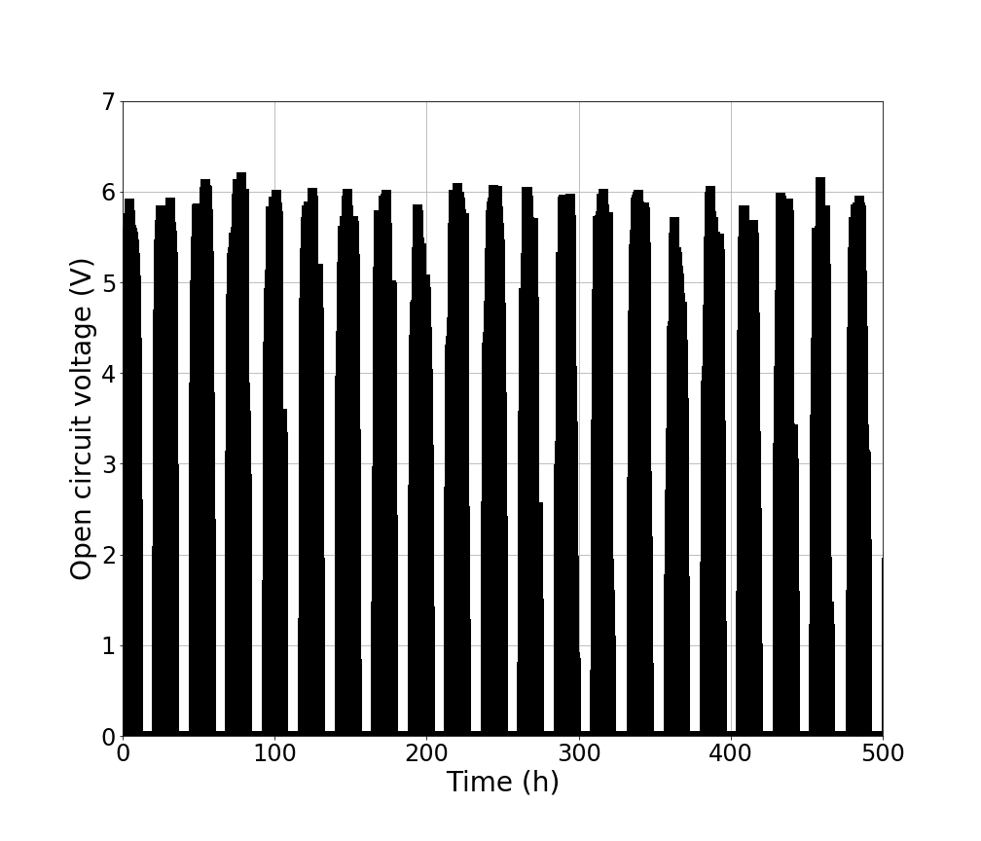
PSM 50 cm²

Figure S3. Time evolution for the photovoltaic performance of the PSMs.

a)  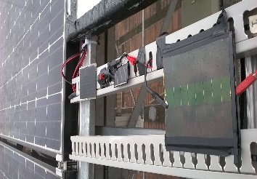 | b)  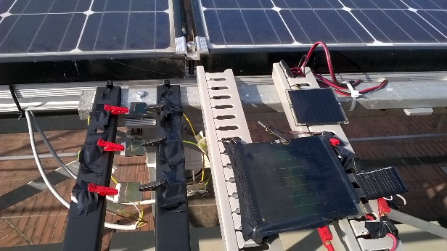
c)  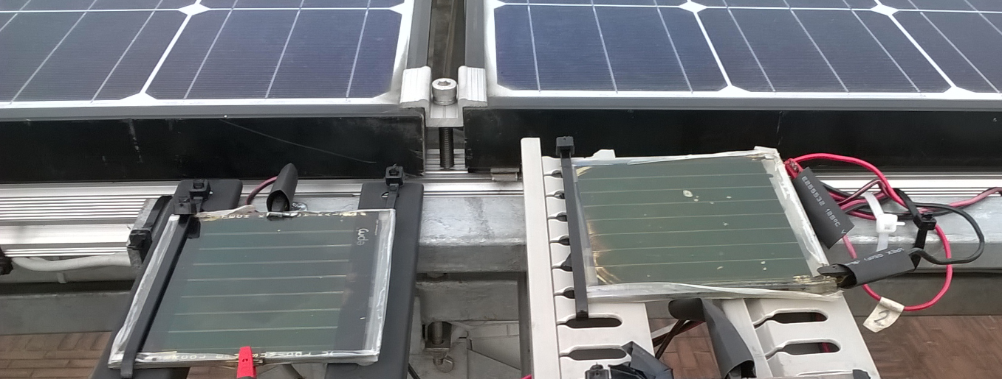 | d)  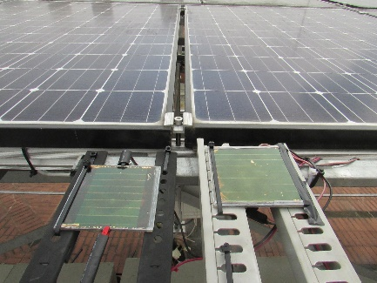

Figure S4. Time evolution of the PSM 17 (top) and PSM 50 (bottom) at 0 (a and c) and 500 (b and d) hours of outdoor exposure

4. Relationship between ambient and device temperature
Relationship between the ambient temperature and surface devices temperature during the exposure.
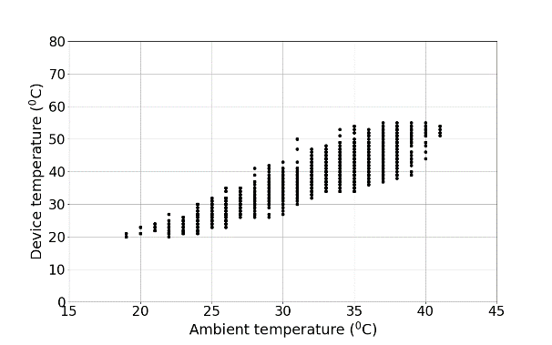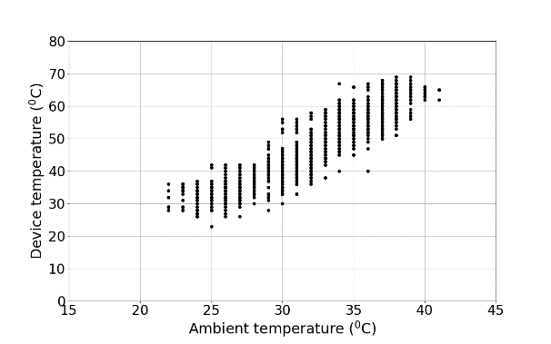
PSM Si
Figure S5. Relationship between ambient and surface devices temperature

5. Linear behavior of devices with atmospheric variables

The linearity of the P_{max} and I_{sc} with irradiance is showed using the frequency distribution plot of these variables. Then this linearity is validated by fitting the data to a linear polynomial.
PSM 17 cm ² | PSM 50 cm² | Silicon
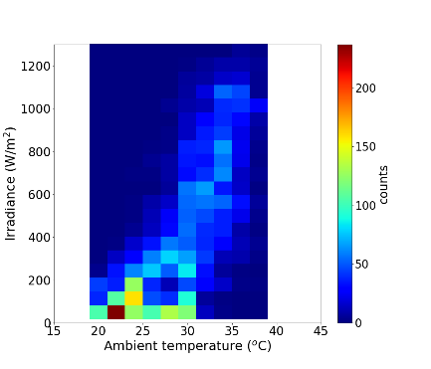 | 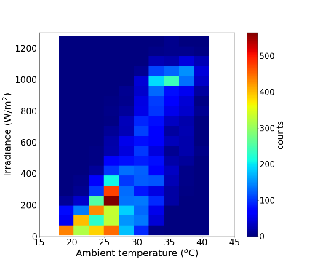 | 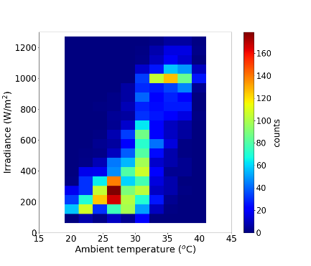
Frequency distribution of atmospheric variables measured in the exposure time
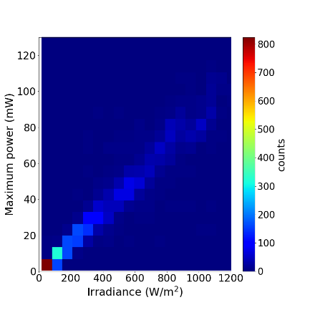 | 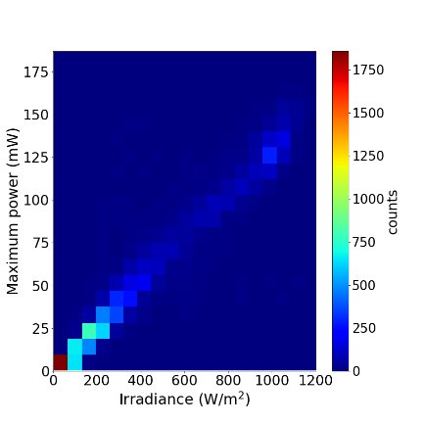 | 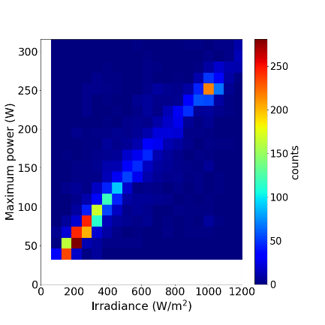
Frequency distribution: all data
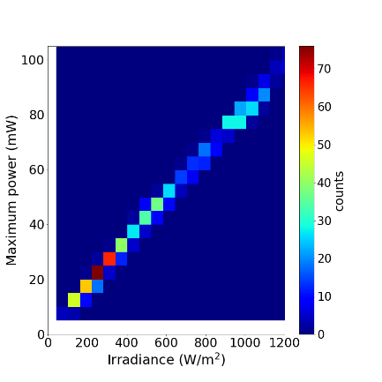 | 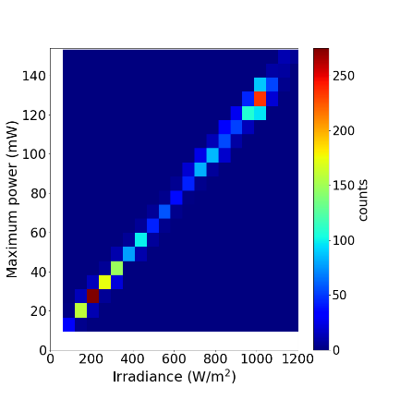 | 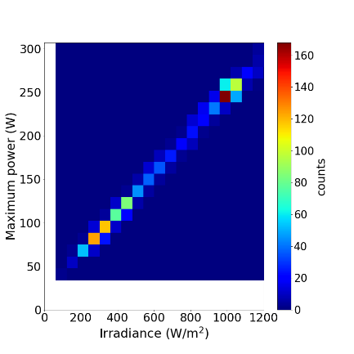
Frequency distribution: Filtered data
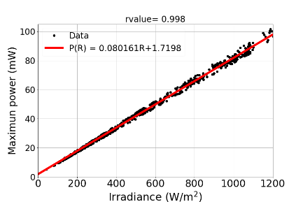 | 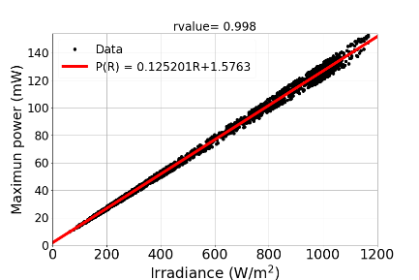 | 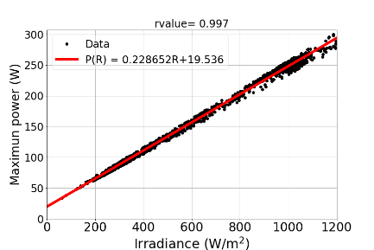
Fitted of Pmax vs irradiance
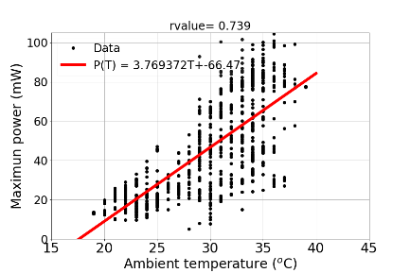 | 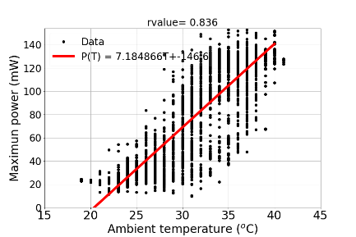 | 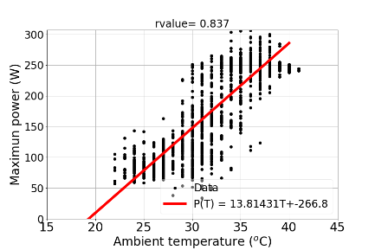
Fitted of Pmax vs temperature
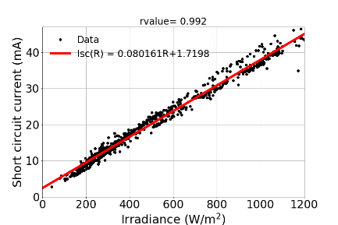 | 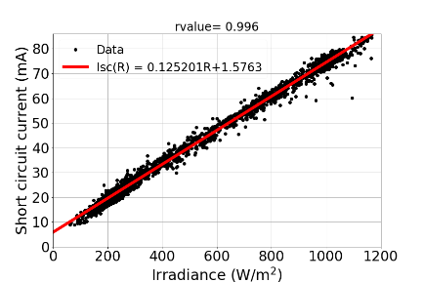 | 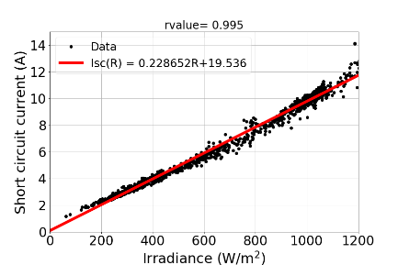
Fitted of Isc vs irradiance
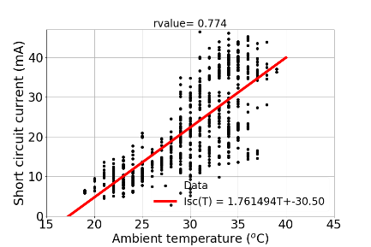 | 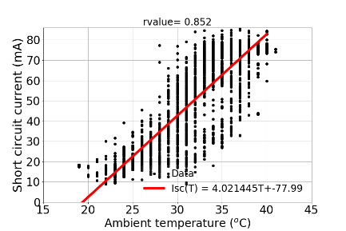 | 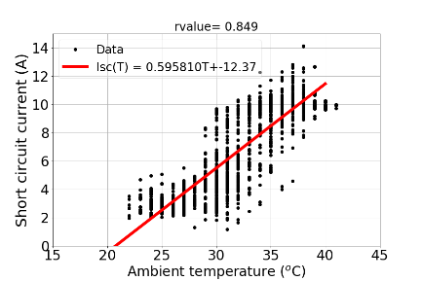
Fitted of Isc vs temperature
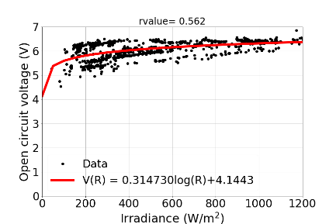 | 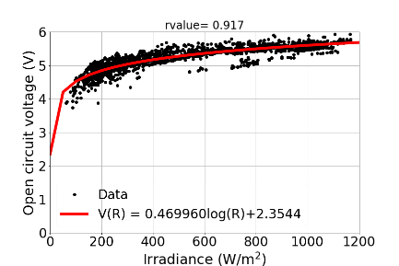 | 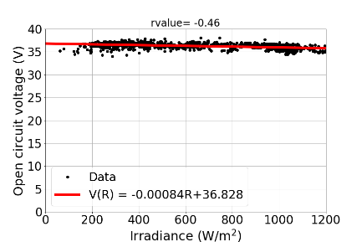
Fitted of Voc vs irradiance
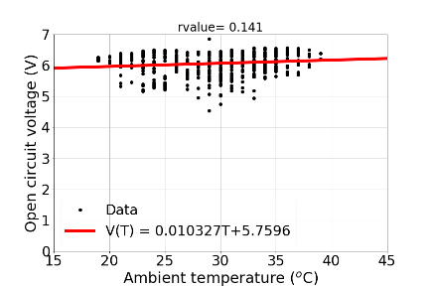 | 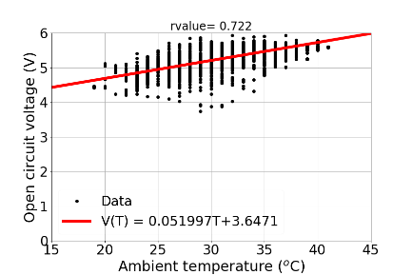 | 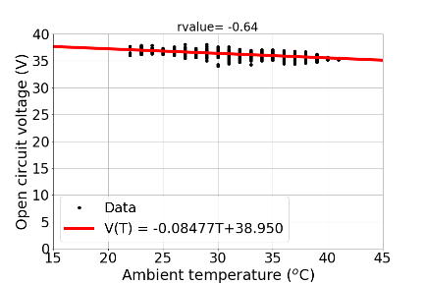
Fitted of Voc vs temperature

Figure S6. Variation of the photovoltaic parameters of the PSMs with the atmospheric variables

6. Real electrical performance

The raw maps of P_{max}, I_{sc} and V_{oc} of the modules and silicon panel as a function of irradiance and ambient temperature considering the whole data registered.
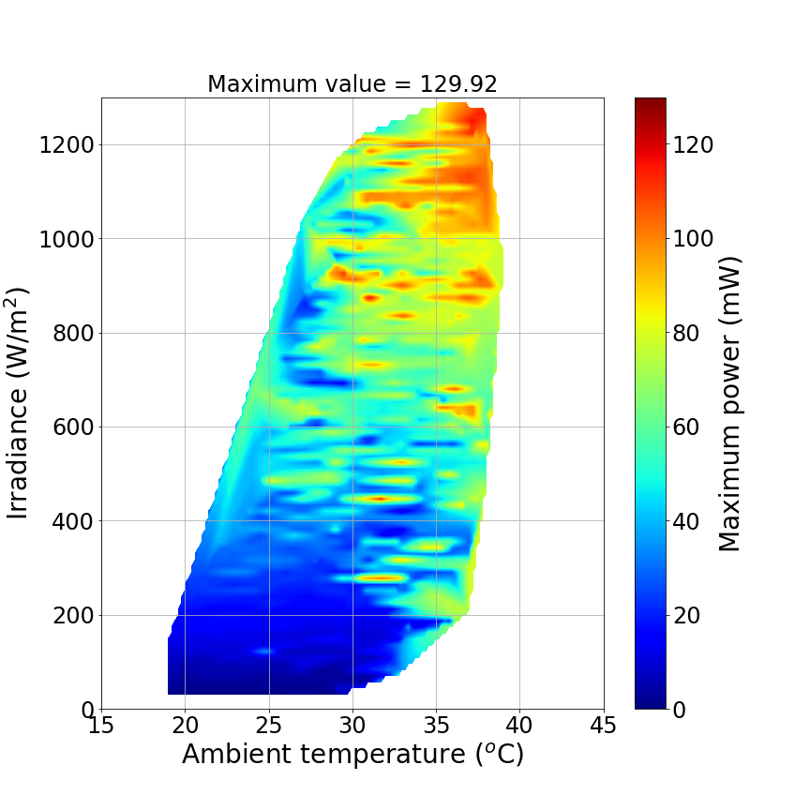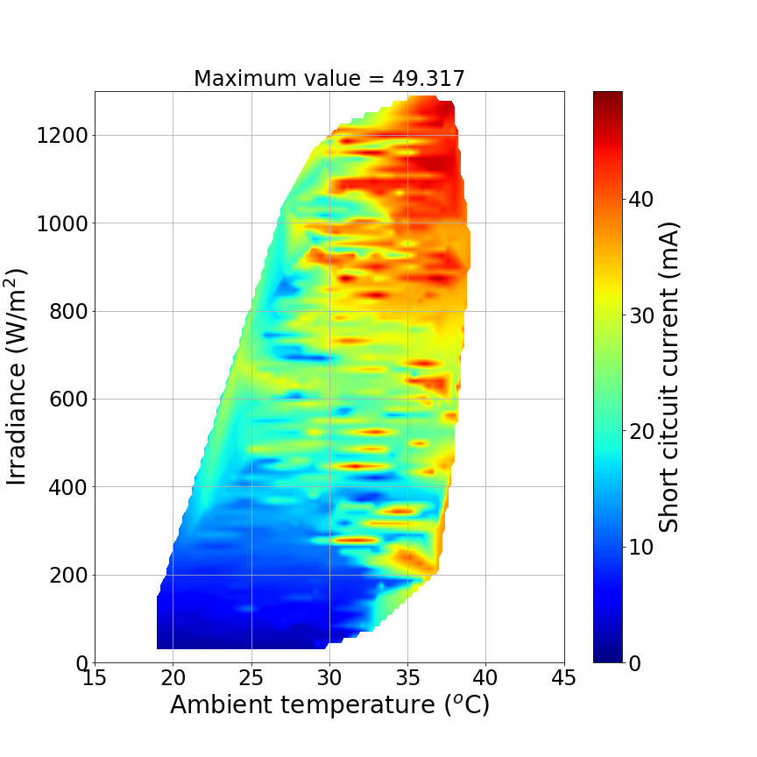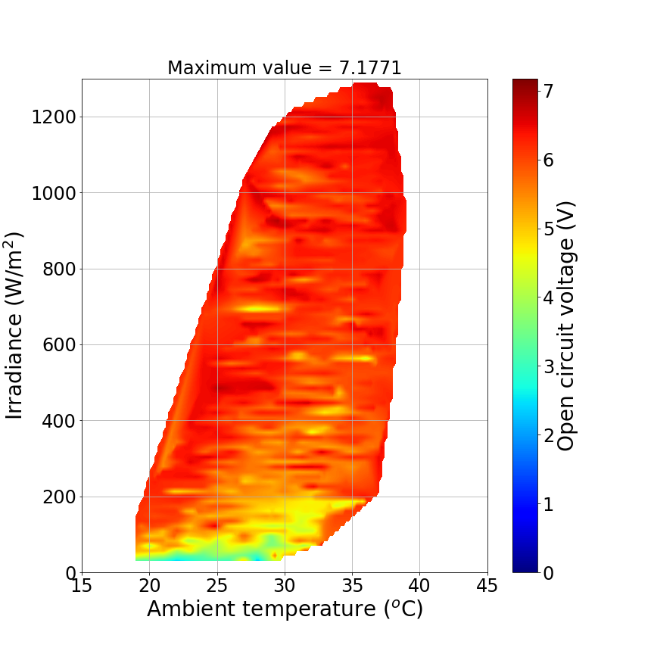
PSM 17 cm²
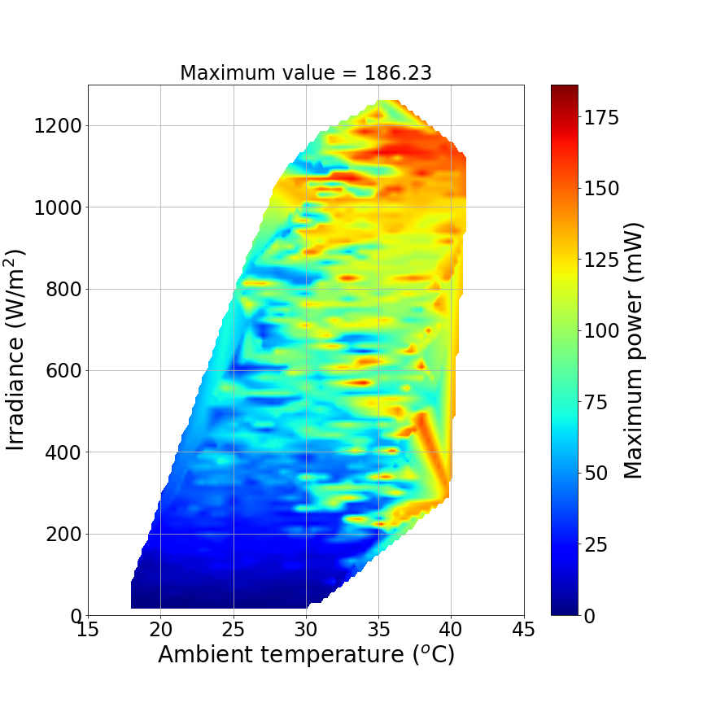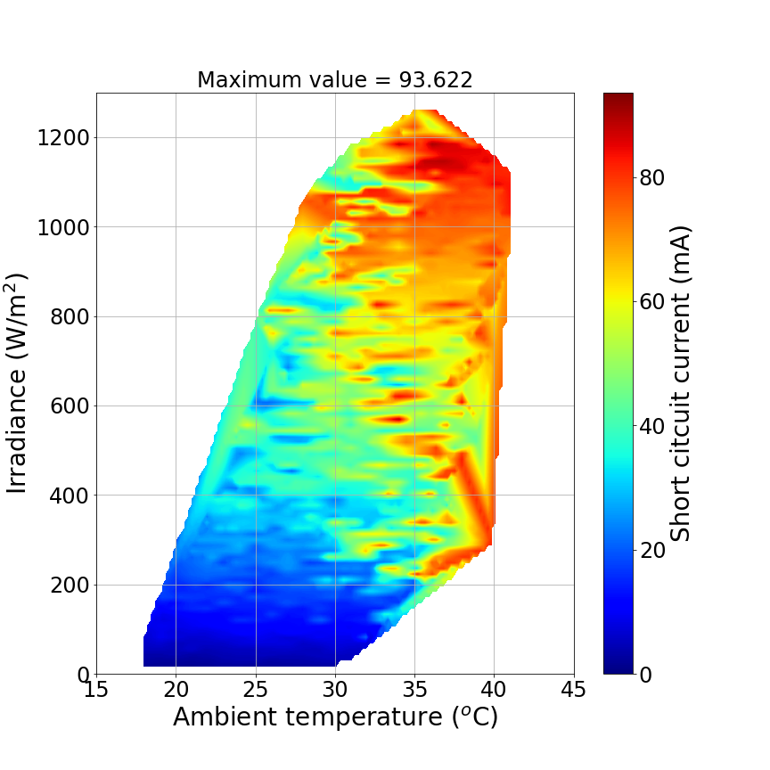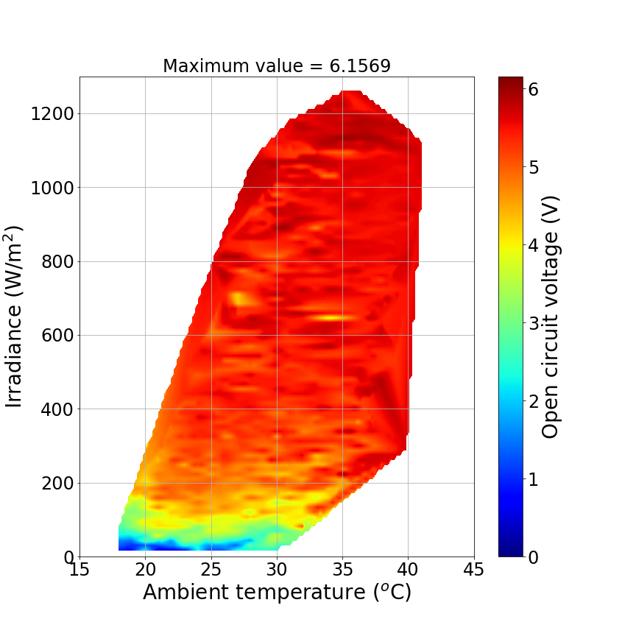
PSM 50 cm²
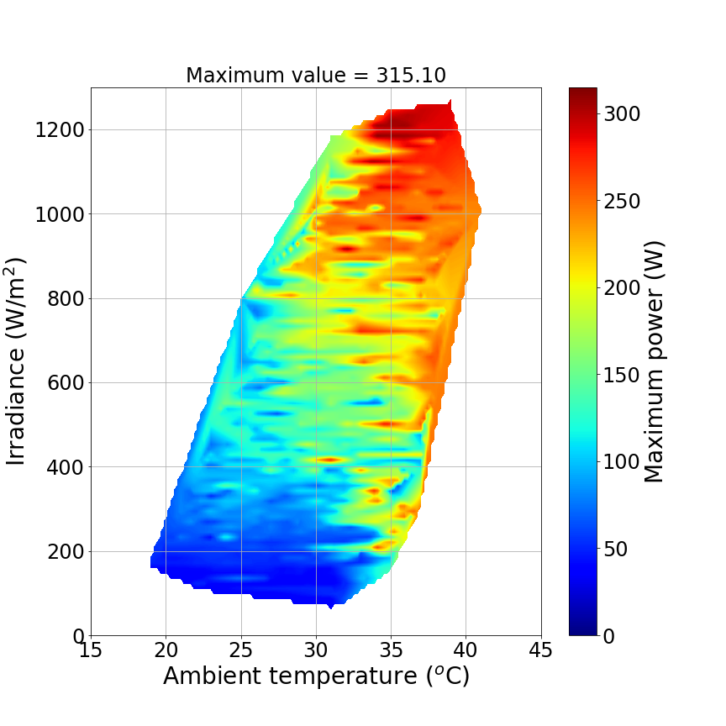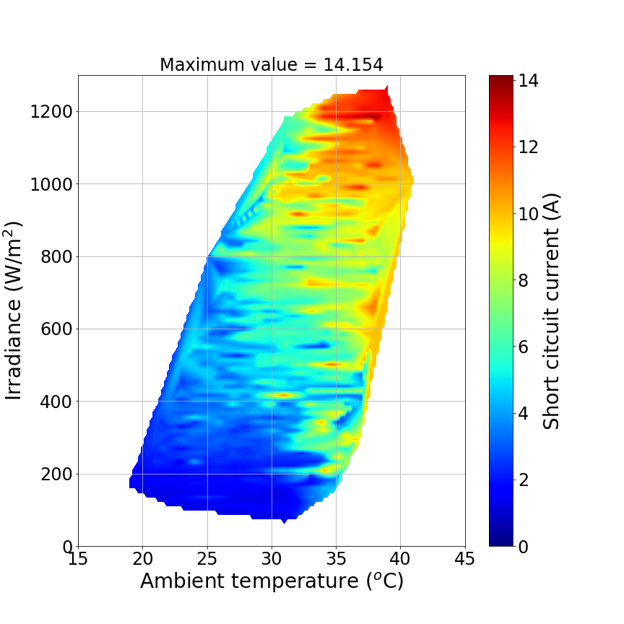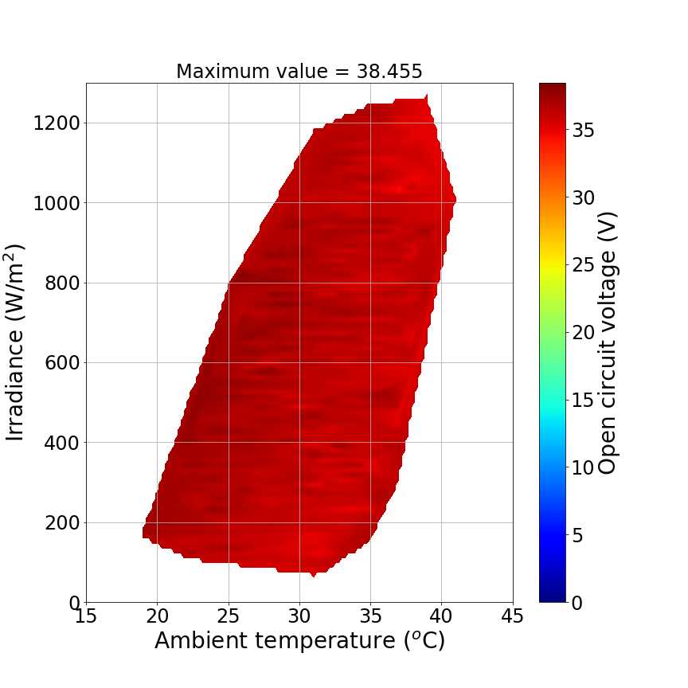
Silicon
Figure S7. Real electrical performance maps

